**Lesson 02 Demo 01**

**Implementing a React Routing Application**

**Objective:** To implement React routing for navigating between various components

**Tools required:** Node.js and React.js

**Prerequisites:** None

Steps to be followed:

1. Create a React project
2. Install routing dependencies and their features
3. Create different components for routing
4. Create a NavBar.js component file
5. Add the Bootstrap features to the project
6. Test the application

**Step 1: Create a React project**

1. Open a terminal window to create a React project by executing the below command:

**npm create-react-app simple-react-app-routing**

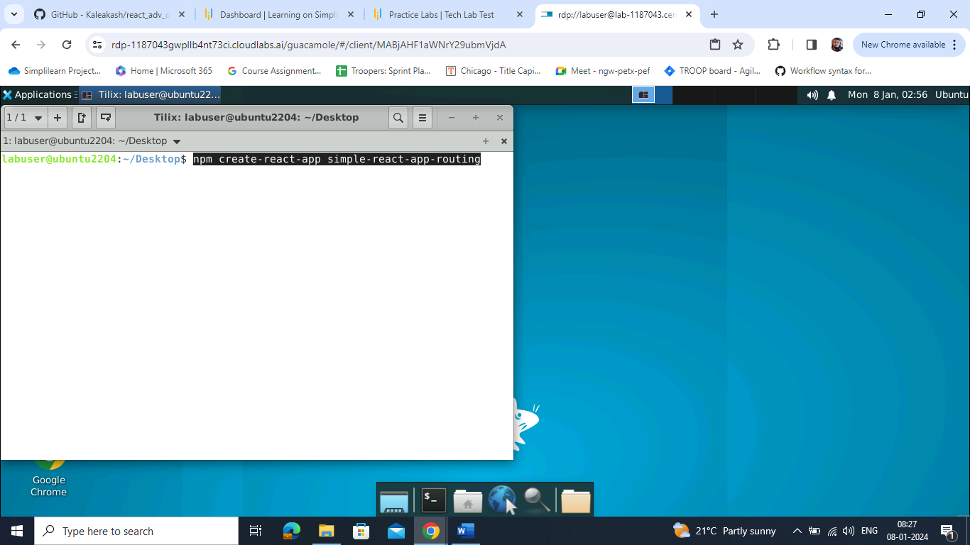

1. Open the created React application folder (**simple-react-app-routing**) in VS Code by clicking on **File** in the top left corner and selecting **Open Folder**

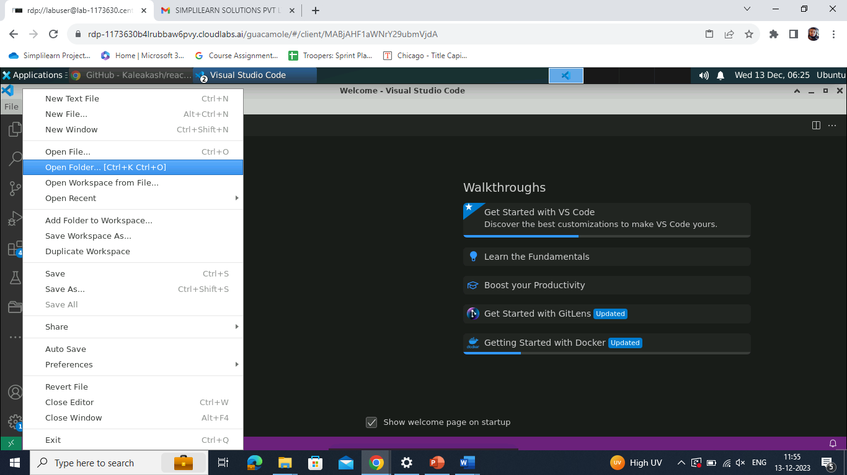

1. Select the project where it is created and click on **Open**

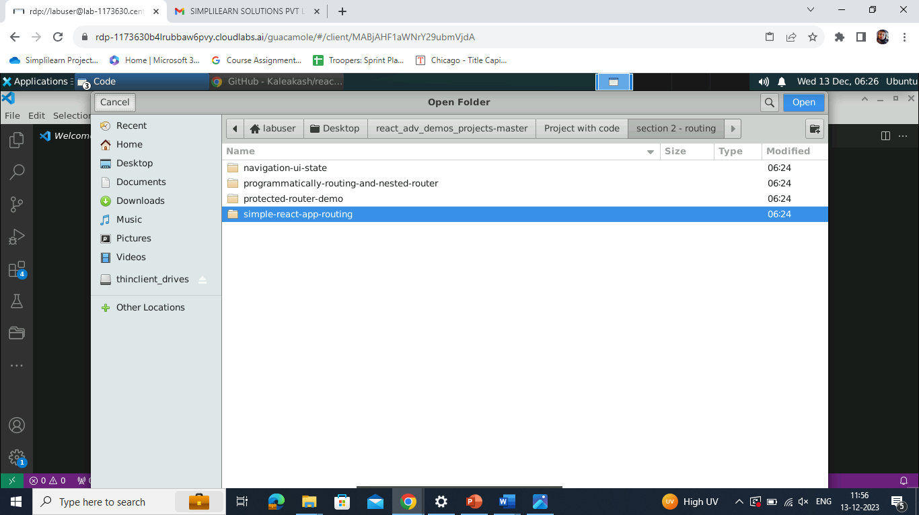

The folder structure appears as follows:

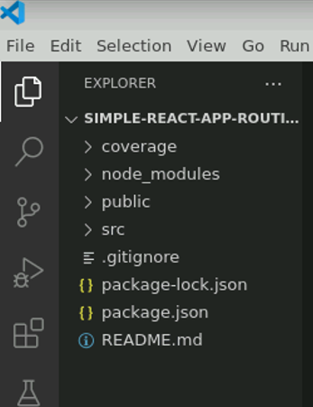

**Step 2: Install routing dependencies and their features**

* 1. Open the terminal inside the project and run the following command to download the dependencies:

**npm install**

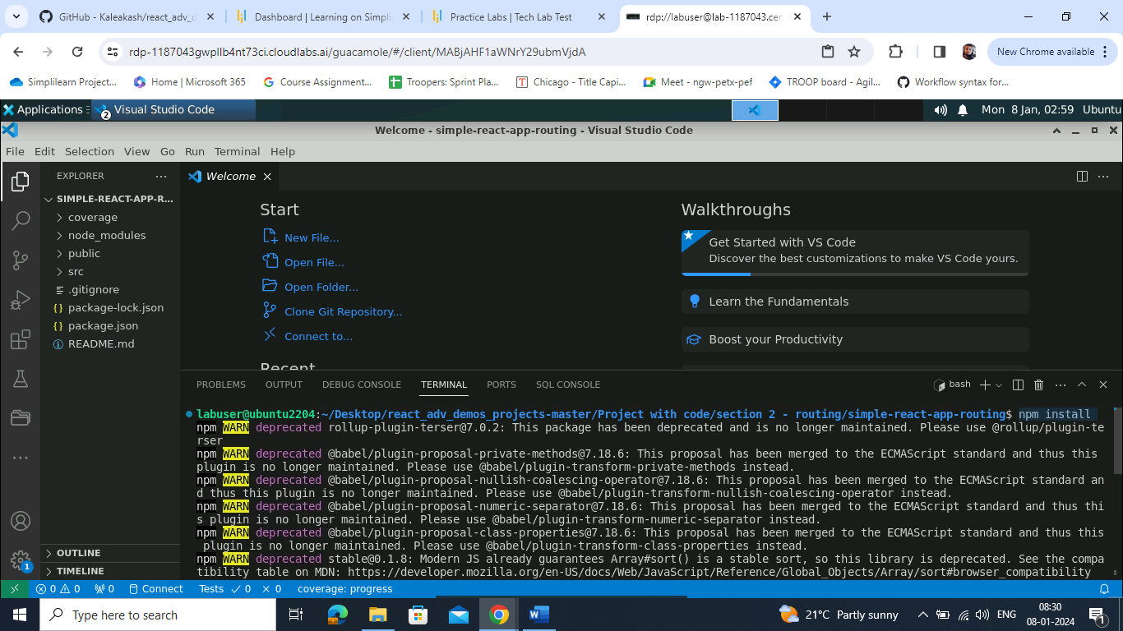

* 1. Now, use the following command to install routing dependencies:

**npm install react-router-dom**

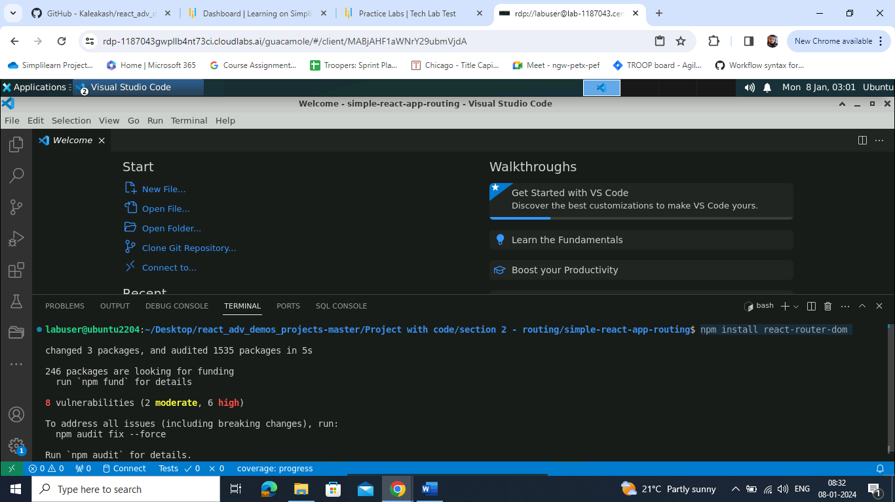

* 1. Check the dependencies in the **package.json** file

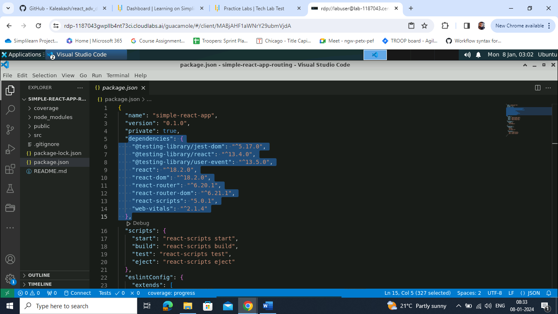

* 1. Write the following code in the **index.js** file to add the **BrowserRouter** tag that enables routing features to the whole application:

**import React from 'react';**

**import ReactDOM from 'react-dom/client';**

**import './index.css';**

**import App from './App';**

**import reportWebVitals from './reportWebVitals';**

**import {BrowserRouter} from 'react-router-dom'**

**const root = ReactDOM.createRoot(document.getElementById('root'));**

**root.render(**

**<React.StrictMode>**

**<BrowserRouter>**

**<App />**

**</BrowserRouter>**

**</React.StrictMode>**

**);**

**// If you want to start measuring performance in your app, pass a function**

**// to log results (for example: reportWebVitals(console.log))**

**// or send to an analytics endpoint. Learn more: https://bit.ly/CRA-vitals**

**reportWebVitals();**

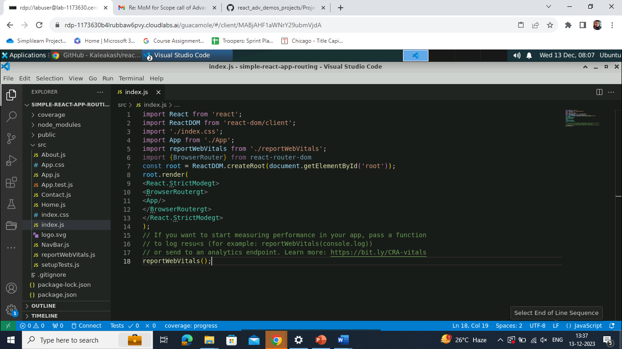

**Step 3: Create different components for routing**

1. Inside the **src** folder, create a **Home.js** component file and write the following code:

**function Home() {**

**return(**

**<div>**

**<h2>Home Component</h2>**

**</div>**

**)**

**}**

**export default Home;**

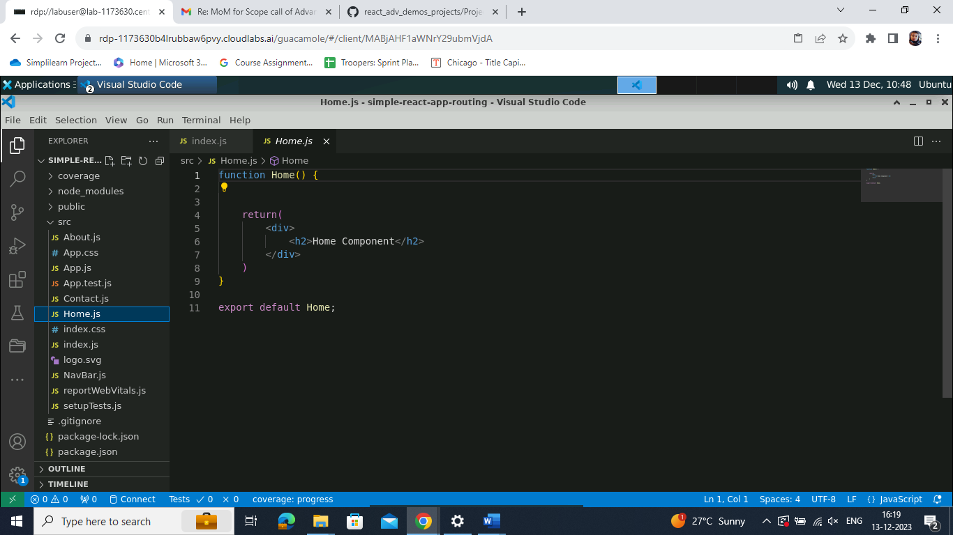

1. Create an **About.js** component file and add the following code:

**function About() {**

**return(**

**<div>**

**<h2>About Us Component</h2>**

**</div>**

**)**

**}**

**export default About;**

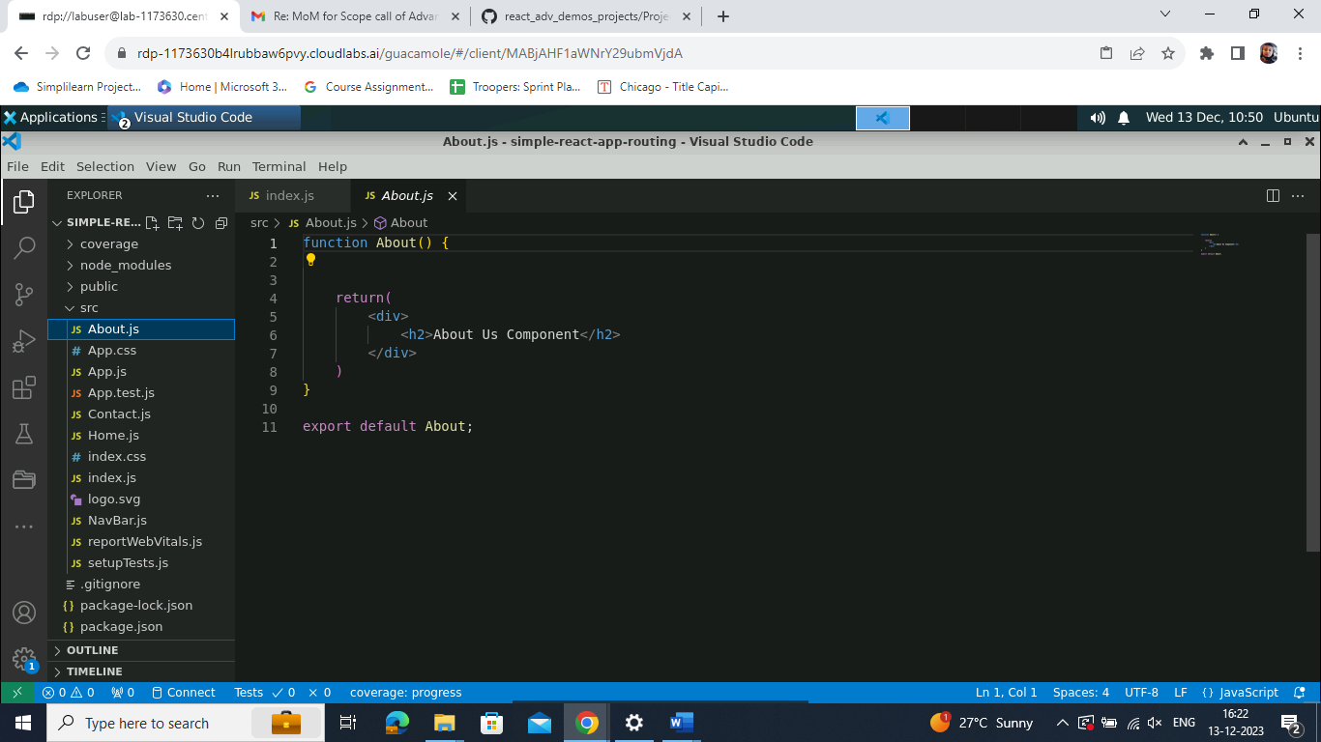

1. Create a **Contact.js** component file and write the following code:

**function Contact() {**

**return(**

**<div>**

**<h2>Contact Component</h2>**

**</div>**

**)**

**}**

**export default Contact;**

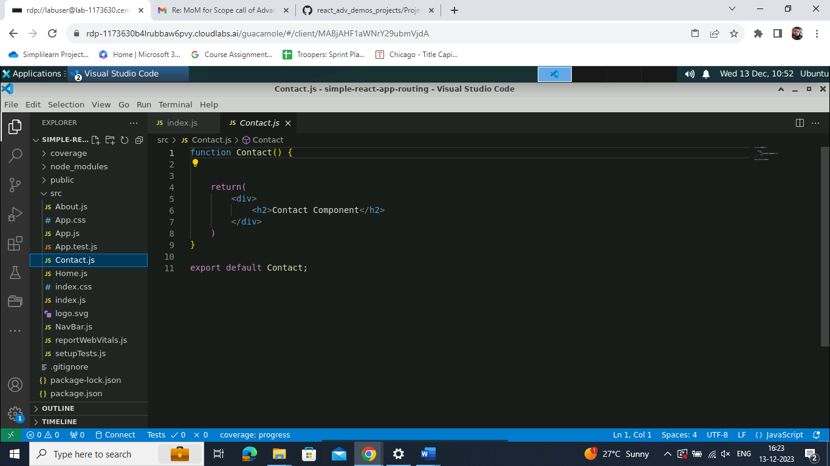

**Step 4: Create a NavBar.js component file**

1. Create the **NavBar.js** file. This file holds the navigation rules, allowing you to move between different components. Write the following code in **NavBar.js** file:

**import React from 'react';**

**import { NavLink } from 'react-router-dom';**

**const NavBar = () => {**

**return (**

**<div>**

**<nav>**

**<div className="nav-items container">**

**<div className="logo">**

**<a href="/">**

**<h1>Router App</h1>**

**</a>**

**</div>**

**<ul>**

**<li>**

**<NavLink to="/">Home</NavLink>**

**</li>**

**<li>**

**<NavLink to="/about">About Us</NavLink>**

**</li>**

**<li>**

**<NavLink to="/contact">Contact Us</NavLink>**

**</li>**

**</ul>**

**</div>**

**</nav>**

**</div>**

**);**

**};**

**export default NavBar;**

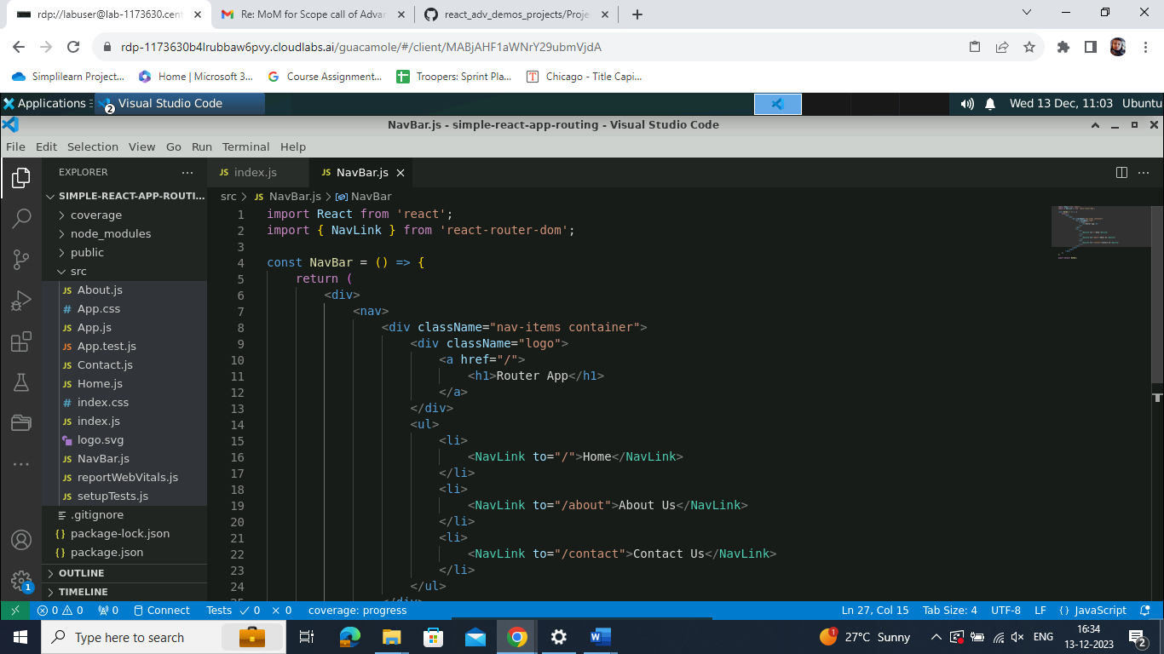

**Step 5: Add the Bootstrap features to the project**

1. Incorporate the following Bootstrap Content Delivery Network (CDN) link into the **index.html** page:

**<link href="https://cdn.jsdelivr.net/npm/bootstrap@5.0.2/dist/css/bootstrap.min.css"rel="stylesheet"integrity="sha384EVSTQN3/azprG1Anm3QDgpJLIm9Nao0Yz1ztcQTwFspd3yD65VohhpuuCOmLASjC" crossorigin="anonymous">**

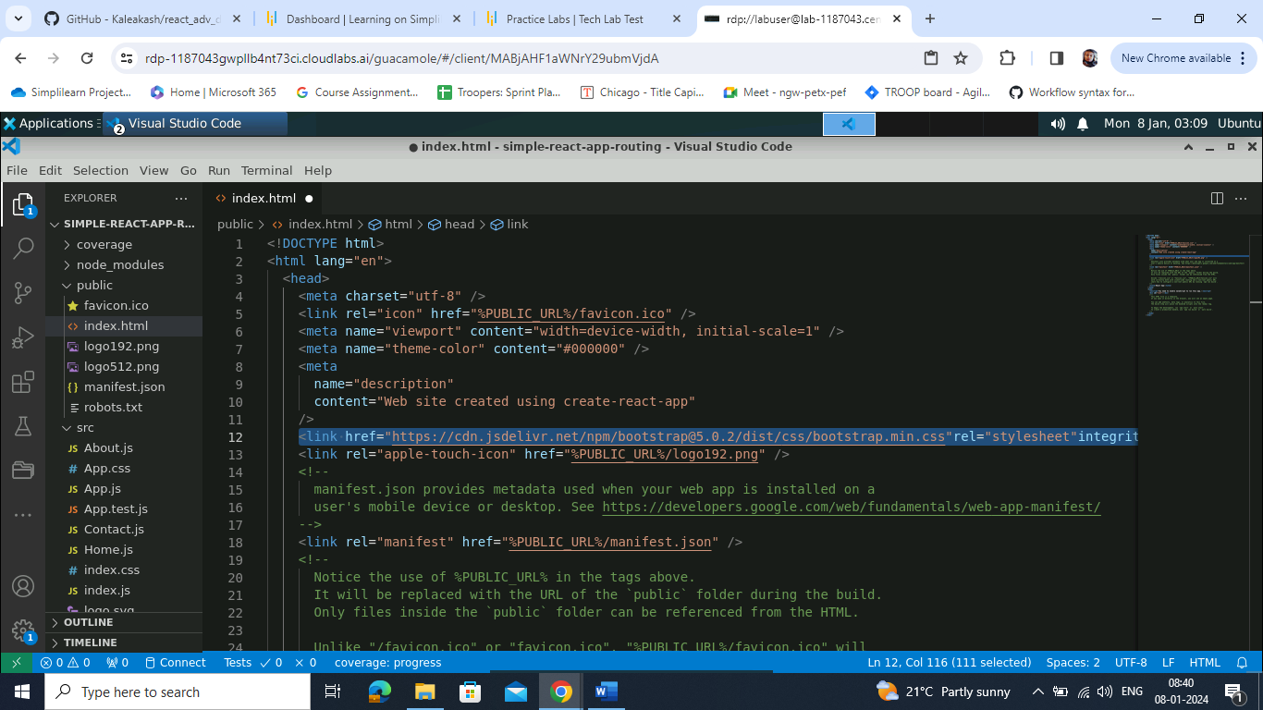

1. Create an **app.js** file under the **src** folder and import all components by writing the following code:

**import logo from './logo.svg';**

**import './App.css';**

**import WithoutUseMemo from './WithoutUseMemo';**

**import WithUseMemo from './WithUseMemo';**

**import UseMemoWithDependency from './UseMemoWithDependency';**

**function App() {**

**return (**

**<div className="App">**

**<WithoutUseMemo></WithoutUseMemo>**

**<WithUseMemo></WithUseMemo>**

**<UseMemoWithDependency></UseMemoWithDependency>**

**</div>**

**);**

**}**

**export default App;**

**Note:** It adds a logo and some styles. It also includes three sections (components) named **WithoutUseMemo**, **WithUseMemo**, and **UseMemoWithDependency**. These sections represent different parts of the webpage.

1. Write the following rules inside the **App.js** file:

**import './App.css';**

**import {Routes,Route, Link} from 'react-router-dom'**

**import Home from './Home';**

**import About from './About';**

**import Contact from './Contact';**

**import NavBar from './NavBar';**

**function App() {**

**return (**

**<div className="App">**

**<NavBar />**

**<hr/>**

**<Routes>**

**<Route path="/" element={<Home/>}></Route>**

**<Route path="/about" element={<About/>}></Route>**

**<Route path="/contact" element={<Contact/>}></Route>**

**</Routes>**

**</div>**

**);**

**}**

**export default App;**

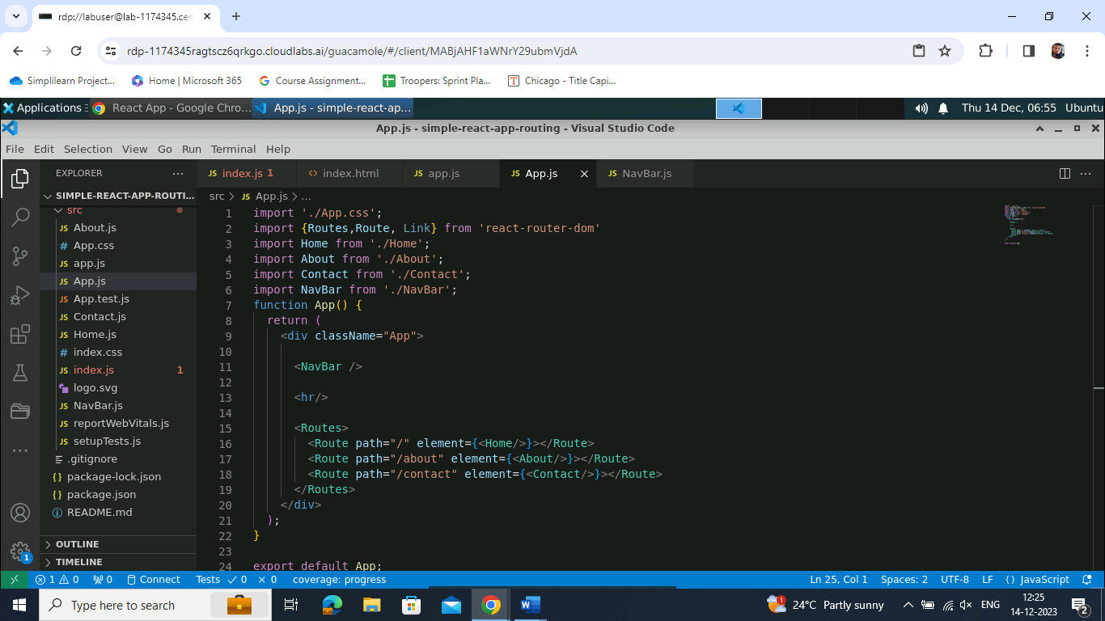

**Step 6. Test the application**

1. Run the following command to test the application:  
     
   **npm start**

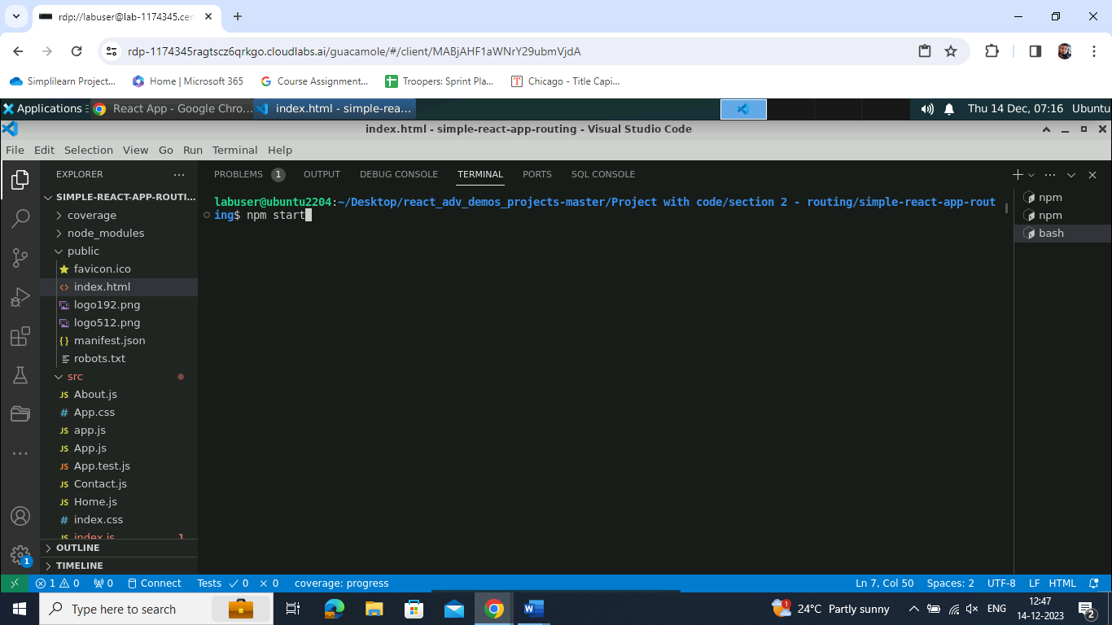

Output will look as follows:

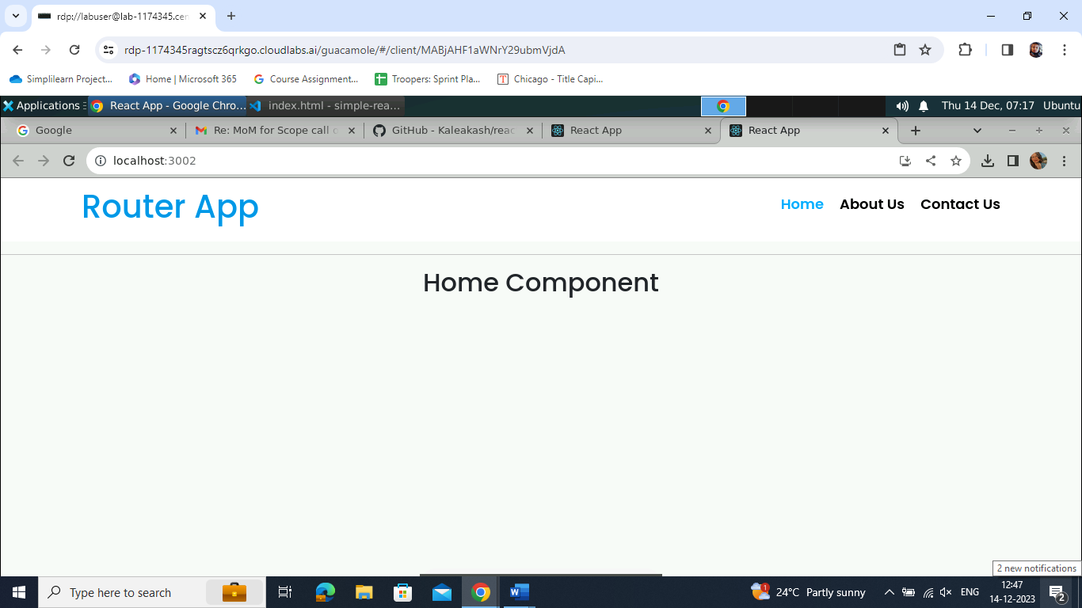

1. Perform testing by clicking on the **About Us** component

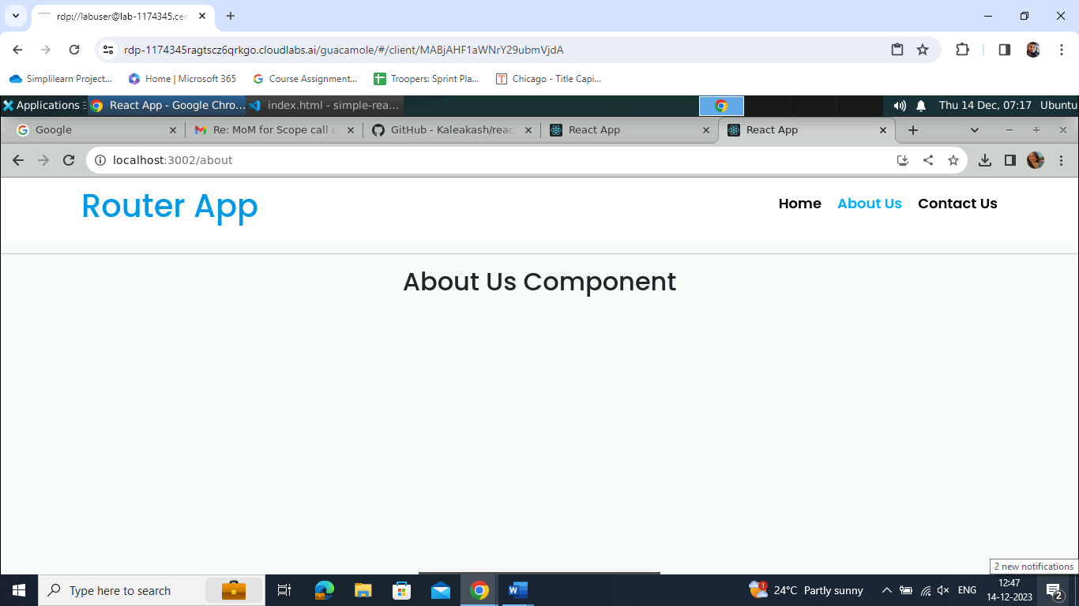

1. Click on the **Contact Us** component

With this, you have effectively implemented React routing, enabling seamless navigation between different components.